**A.L.E.R.T**

**AREA LAW ENFORCMENT & RETAILERS TEAM**

**Knoxville Tri-Cities**

**PURPOSE**

**The ALERT system is an association of Loss Prevention, Asset Protection and Law Enforcement professionals that work together through communications and networking. The ALERT group allows information to be shared between local retailers and law enforcement. The organization’s primary function is to combat ORC and ORT theft by offering and exchanging information. Although the system’s focus is directed towards ORC and ORT theft, it also provides information for any type of suspicious activity that may have occurred, whether it is from a retailer or law enforcement.**

**NETWORKING**

**The ALERT system can be used by email or through a web base. The email system is typically run by one business or agency that stores multiple user emails. Once a user sends information by email to the business or agency, the system automatically sends the alert information to all subscribers of the system. The web base version is a database that stores information reported by retailers and law enforcement. The web base is provided by Shelby County Sheriff’s Office. The web base serves all states and cities in the United States.**

**METHOD**

**The use of the ALERT system enables the retailer to send the suspect’s vehicle information and photograph to law enforcement and other retailers for review and identification. The system also allows other retailers and law enforcement to be on the lookout for the suspects in their own location.**

**SUMMARY**

**Retailers and law enforcement rely heavily on the exchange of information to proficiently combat theft. The Alert system provides retailers and law enforcement a communication connection that usually is not established in a specific area without forming an alert group.**

**Local retailers have helped bring and establish the ALERT system to the Knoxville and Tri-Cities area of Tennessee. The Knoxville ALERT was established through The Knox County Sherriff’s Office, who supports the email system. The Knoxville ALERT includes participants from area law enforcement agencies and multiple retailers such as Food City, Sears, Kohl’s, Wal-Mart, CVS, Kroger, TJ Max, Target and Marshals. The Knoxville ALERT organization is entirely established and networking. By establishing and using the Knoxville ALERT system, Food City, along with other retailers, has been successful at identifying and prosecuting suspects to the maximum extent of the law. The Knoxville Alert is currently meeting quarterly.**

**The Tri-Cities ALERT system recently accomplished their first step in organizing local law enforcement and retailers by coming together and meeting as a group. The meeting took place at Food City on Euclid Avenue. Twenty-one representatives of law enforcement agencies and local retailers such as Food City, Sears, Kroger, CVS, Belk, and Wal-Mart attended. During the meeting, multiple topics were covered addressing ORC and ORT as well as what type of ALERT system the group would like to use. The Tri-Cities ALERT will provide networking from Greeneville, Tennessee up to Marion, Virginia. The Tri-Cities ALERT is facilitated by the Sullivan County Sheriff’s Office. The next meeting will be held in September.**

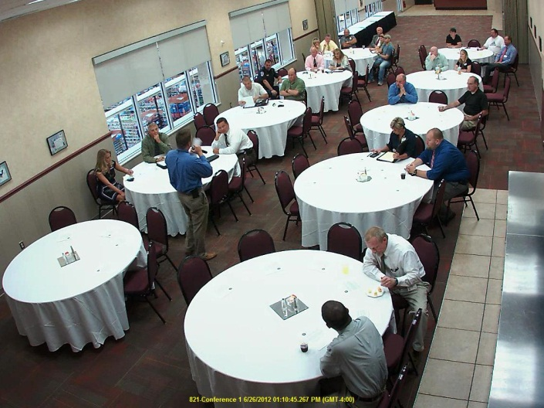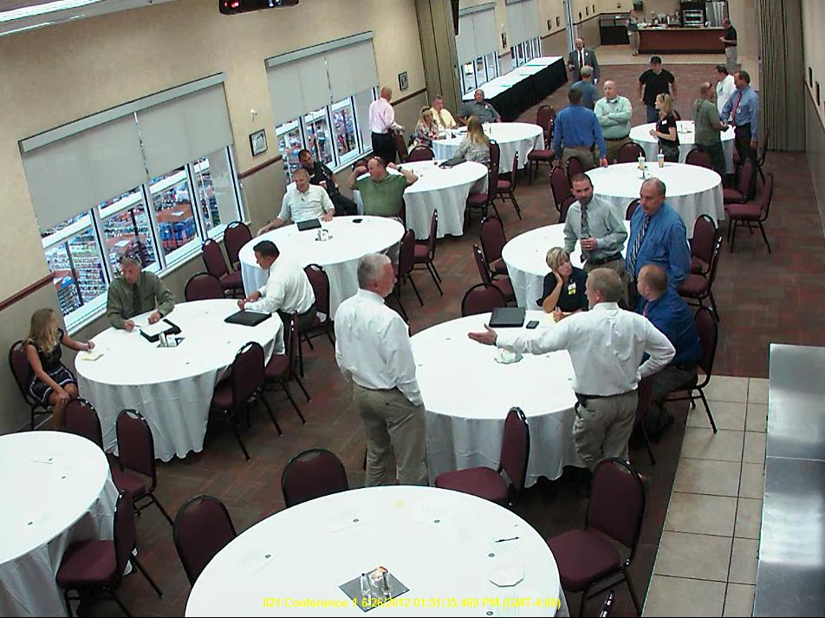

**Tri-Cities ALERT Meeting**