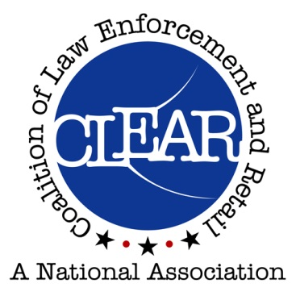

**CLEAR**

**Eighth Annual Training Conference**

**MONDAY, OCTOBER 16, 2017**

**2:00pm – 4:30pm Board of Directors Meeting**

**2:30pm – 4:30pm Vendor Exhibit Set up**

**4:30pm – 6:00pm Pre-registration and Vendor Exhibits**

**7:00pm – 9:00pm Welcome Reception – Hospitality Room**

**TUESDAY, OCTOBER 17, 2017**

**7:15am – 8:00am Registration**

**8:00am – 5:00pm Conference and Vendor Exhibits**

**WEDNESDAY, OCTOBER 18, 2017**

**8:00am – 5:00pm Conference and Vendor Exhibits**

**THURSDAY, OCTOBER 19, 2017**

**8:00am – 12:00pm Conference and Vendor Exhibits**

On line registration available at [www.clearusa.org](http://www.clearusa.org).

For more information, please call

**Mark: 801-799-3764 mark.falkner@slcgov.com**

**Curt: 208-570-6232 ccrum@cityofboise.org**

**adhkdhakjhdkah**



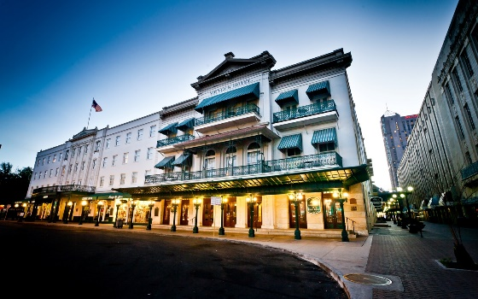

Menger Hotel

San Antonio, Texas

204 Alamo Plaza San Antonio TX 78205

210-223-4361

Downtown location

Near Riverwalk

Right next to Alamo

Hotel Rate:  $120 plus taxes

(Parking: $20 Valet. Other parking $12-$20 per day)

Ask for the Coalition of Law Enforcement and Retail

Group rate

Price $175.00 per person

Receive CFE Credit

Come join us for the training, the networking, and the fun

*Success through partnership*